THE TROUBADOUR EXPERIENCE 9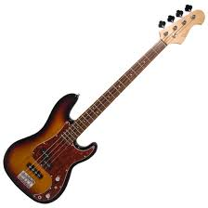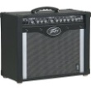IEM
8 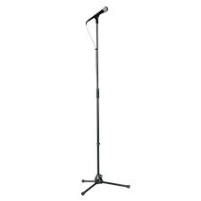 10 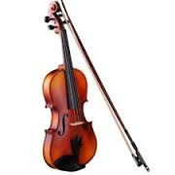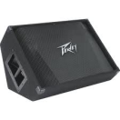Wedge

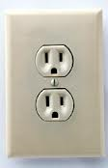Power Center Stage
711 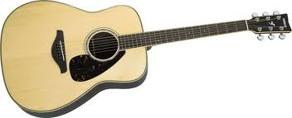 IEM 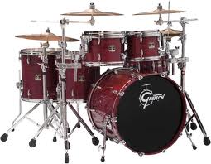IEM + Wedge

12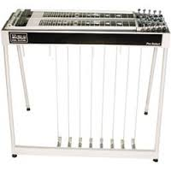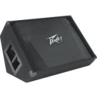 Wedge

13 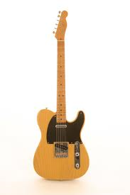

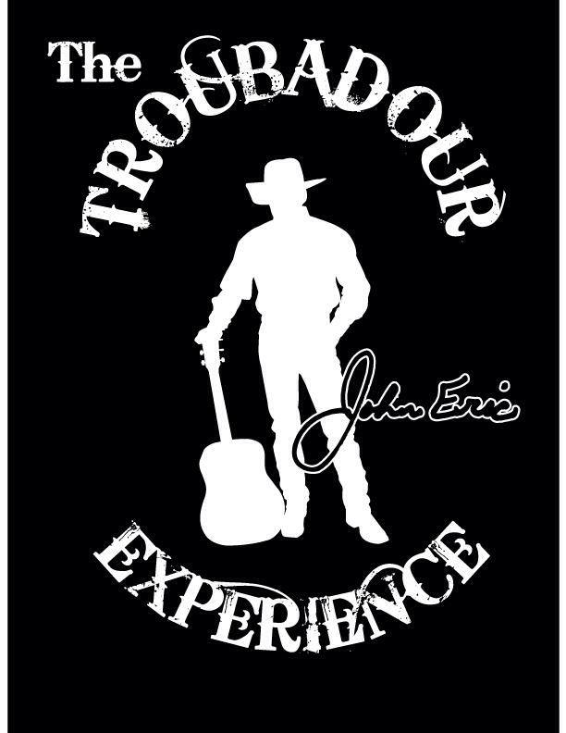
INPUT LIST
1. KICK
2. SNARE
3. RACK TOM
4. FLOOR TOM
5. HI HAT
6. OVERHEAD
7. VOCAL CENTER STAGE-JOHN
8. VOCAL STAGE RIGHT-TONY
9. BASS
10. FIDDLE
11. ACOUSTIC GUITAR
12. STEEL GUITAR
13. LEAD GUITAR
Lead guitar player has his own personal hot spot monitor.

